Local Government Boundary Review of North Yorkshire Council.

North Yorkshire Council was set up in 2022 with interim electoral divisions put together from a mixture of the old borough wards and the old county divisions. As interim divisions, many of these are of different sizes. Part of the process of setting up the new council is a review of the county divisions to redraw them to bring electoral equality. This process officially started in December 2023, to be completed by August 2025 in time for the 2027 elections.

The process is in two or three stages:
December 2023 to June 2024 Determine number of county councillor
1 October to 6 December 2024 Consultation on new division boundaries
Spring 2025 to Summer 2025 Possible second consultation on recommended boundaries

The review has decided that North Yorkshire Council is to have 89 councillors, which results in a forecast division quota (the average number of electors per division) of 5818. Submissions have to be based on the electorate on 1st Jan 2023, and the supplied forecast for the 2030 electorate.

As with the 2019 review of Scarborough Borough Council, I recommend that Whitby Town Council makes the case that the Town Council area should be co-terminal with a whole number of county divisions. The Town Council is currently covered by two county divisions: Whitby West and Whitby Streonshalh. Although each division on its own is mis-sized and will need adjusting, the two divisions taken together are very close to the quota for exactly two divisions with 89 county councillors.

2023 Whitby electorate 10208 1.9seats
2030 Whitby forecast 11377 2.0seats
County quota 5818 89 seats

NYC have previously stated that governance reviews of the towns and parishes will be done after the country review is completed. SBC previously committed to having a governance review before they were abolished. This subsequent parish review will be the opportunity to review the size of the town council and the town’s own warding arrangements, and make adjustments resulting from the county review.

Consequently, I recommend that Whitby Town Council submits the following recommendation to the Local Government Boundary Commission; and also to North Yorkshire Council and the two Whitby NYC councillors – Cllr Trumper and Cllr Swannick - to inform their decision-making process.

Barry Khan
Assistant Chief Executive (Legal and Democratic Services)
County Hall
Northallerton
DL7 8AD

Review Officer (North Yorkshire)
LGBCE
1st Floor, Windsor House
50 Victoria Street
London SW1H 0TL Email
reviews@lgbce.org.uk

Submission from Whitby Town Council regarding the
Local Government Boundary Review of North Yorkshire Council.
Stage Two: Division Boundaries

Whitby Town Council submits this representation regarding the county divisions in the area covered by Whitby Town Council.

As with the 2019 review of Scarborough Borough Council, we recommend that the area of Whitby be co-terminal with a whole number of county divisions. The Town Council is currently covered by two county divisions: Whitby West and Whitby Streonshalh. Although each division on its own is mis-sized and will need adjusting, the two divisions taken together are very close to the quota for exactly two divisions with the proposed 89 county councillors.

2023 Whitby electorate 10208 1.9seats
2030 Whitby forecast 11377 2.0seats
County quota 5818 89 seats

Whitby has a distinct local identity. The greater Whitby District, broadly the Esk Valley basin, also has a distinct local identity. The area has a distinct character and community of its own. Whitby is isolated on all sides, by the moors to the landward side and the sea to the other. The geography funnels the focus of the area towards Whitby which is the focus for local facilities and forms the urban core. The Town Council is also wholly outside the North Yorkshire National Park, with the Park boundary being coterminal with the Town Council boundary other than the north-western border with Sandsend.

We believe that addressing the criteria of Interests and Identities of Local Communities and Effective and Convenient Local Government and would be best served if Whitby had a whole number of county councillors with no county division overlapping outside the Town Council area.

There are currently exactly two county divisions covering Whitby Town. With the 2030 quota they are mis-sized, one 15% undersized, and the other just over 10% too big. With a small adjustment involving transferring a handful of streets in the town centre, transferring about 775 electors, the two divisions can be adjusted to bring them both close to quota. This would be a small change to achieve electoral equality, and would follow lines clearly distinct on the ground.

2030 forecast 2030 forecast
Current divisions Recommended divisions
Whitby West 6438 1.106seats 5663 0.973 seats
Whitby Streonshalh 4939 0.849seats 5714 0.982 seats
Whitby total electorate 11377 11377

The recommendation is to adjust the existing division boundary by deviating where the existing boundary along the dismantled railway crosses Southend Gardens/Stakesby Vale:
from:
* centre of Southend Gardens, Chubb Hill Road, Back St. Hilda’s Terrace, Skinner Street
to:
* continue along dismantled railway, skirting Beeching Mews to centre of Station Avenue, Argyle Road

The following defaced boundary should also be adjusted, with no change to the electorate:
* The boundary towards the Esk runs along the dismantled railway line underneath Larpool Viaduct. This is very overgrown and is not clear on the ground. The Cinder Path runs along the fork of the dismantled railway line that runs over Larpool Viaduct and is a clear and made-up multi-use path, and is a clearer line on the ground at this point.

This recommended boundary also addresses some anomalies that have resulted over time:
* 2 Byland Road is a new development on the “wrong” side of the pre-2022 country division and borough boundary. There is now no longer anything stopping it being united with the rest of Byland Road.

The recommended new boundary is detailed in the attached map, with the list of streets and electorate transferred.

The new boundary would split the current 2-member Town North parish ward. There are two simple options to address this:
* split the current 2-member Town North parish ward into two 1-member parish wards
* split off the western part of Town North parish ward into a 1-member parish ward, and merge the remainder with the 1-member Town South parish ward to form a 2-member parish ward.

Before they were abolished, Scarborough Borough Council committed to undertaking a parish Local Governance Review to address anomalies and malapportionments that had built up since the last review in 1983. They were not able to do this before being abolished. North Yorkshire Council have similarly stated that they will undertake a Local Governance Review once the county division review is completed. This will be able to address anomalies that result from the division review.

APPENDIX 1
Streets to transfer from Whitby West to Whitby Streonshal:
Street | Number of electors
Southend Gardens | 4
Royal Crescent | 49
Church Square | 29
Hudson Street | 36
Esplanade | 38
Crescent Avenue | 117
John Street | 19
Clarence Place | 7
Well Close Square | 35
Well Close Terrace | 25
St. Hilda's Gardens | 12
Back St. Hilda's | 1
Stonehouse Gardens | 11
Poplar Row | 1
Skinner Street evens 2-36 | 14
Routh Walk | 12
Mulgrave Place | 16
Normanby Terrace | 22
Havelock Place | 16
Abbey Terrace | 47
Langdale Terrace | 29
Crescent Terrace | 2
Westlands Avenue | 20
Southlands Avenue | 11
Newlands Avenue | 12
Field House Road | 5
Spring Vale | 39
Upgang Lane evens 2-42  Upgang Lane odds 1-45 | 109
Argyle Road evens 2-28, Berkley Mansions, Coach House, St. Joseph’s Convent | 37
TOTAL | 775

These are 2023 electorate figures, but population changes to 2030 will make a minimal difference to the balance between the two recommended divisions.

APPENDIX 2
Recommended division boundary within Whitby Town

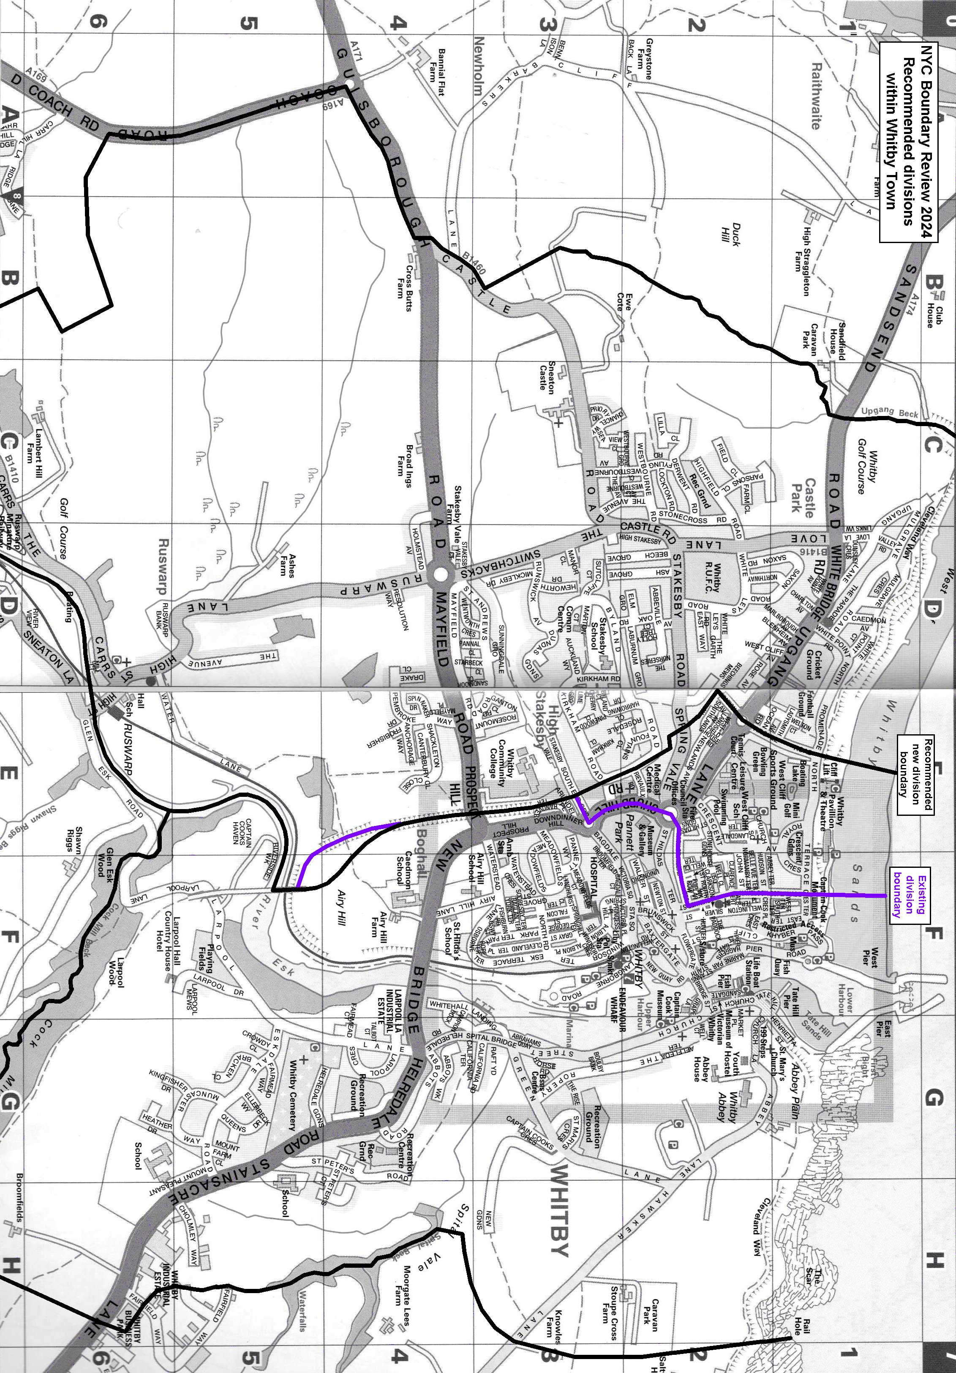
Mapping from Philip’s Red Book Scarborough & Whitby Local Street Atlas

